**Waquoit Bay** (WQB) **NERR Meteorological Metadata**

**October – December 2023**

**Latest Update:** 1/04/2024

Note: This is a provisional metadata document; it has not been authenticated as of its download date. Contents of this document are subject to change throughout the QAQC process and it should not be considered a final record of data documentation until that process is complete. Contact the CDMO ([cdmosupport@baruch.sc.edu](mailto:cdmosupport@baruch.sc.edu)) or reserve with any additional questions.

**I. Data Set and Research Descriptors**

**1) Principal investigator(s) and contact persons –**

Address:

Waquoit Bay National Estuarine Research Reserve

131 Waquoit Highway

PO Box 3092

Waquoit, MA 02536

Website: <http://www.waquoitbayreserve.org>

Contact persons:

Theophilos (Theo) Collins, Research Associate

Email: [Theophilos.j.collins@mass.gov](mailto:Theophilos.j.collins@mass.gov)

Phone: (774) 255-4272, (774) 255-4275

Megan Tyrrell, Research Coordinator

Email: [Megan.tyrrell@mass.gov](mailto:Megan.tyrrell@mass.gov)

Phone: (508) 457-0495; Direct Line: (774) 255-4265

**2) Entry verification –**

The meteorological information is sampled every 5 seconds from each instrument on the weather station and stored on a Campbell Scientific CR1000 data logger. Data are sent to a file in three file formats: CR1000_A5Min.dat stores 5 minute data; CR1000_GOESout.dat stores 15 minute averages that are transmitted hourly for satellite upload; and CR1000_SWMP.dat files stores the 15 minute average data that is submitted to CDMO on a quarterly basis for primary QAQC review. The CDMO Data Logger (NERR_4.CSI) was loaded into the CR1000 and controls the sensors.

Data are uploaded from the CR1000 data logger to a personal computer with a Windows 7 or newer operating system. Files are exported from LoggerNet in a comma-delimited format and uploaded to the CDMO where they undergo automated primary QAQC and become part of the CDMO’s online provisional database. During primary QAQC, data are flagged if they are missing or out of sensor range. The edited file is then returned to the reserve where it is opened in Microsoft Excel and processed using the CDMO’s NERRQAQC Excel macro. The macro inserts station codes, creates metadata worksheets for flagged data and summary statistics, and graphs the data for review. It allows the user to apply QAQC flags and codes to the data, append files, and export the resulting data file to the CDMO for tertiary QAQC and assimilation into the CDMO’s authoritative online database. For more information on QAQC flags and QAQC codes, see Sections 11 and 12.

Although the Eppley pyranometer was installed in 2005 and collected data until 2014, in October 2014 research staff at Waquoit Bay realized the sensor was collecting total solar radiation data in Watt-hours per meter-squared (a measure of maximums within a 15 minute period). CDMO (Centralized Data Management Office) protocols require the total solar radiation data to be displayed in Watts per meter-squared (a measure of 5-second averages over a 15 minute period). Because of the discrepancy, these data have been removed from the national database but are available by request. Please contact the WBNERR research staff for total solar radiation data series (contact information on page 1 of this document).

Theophilos Collins, Research Associate, error checked and compiled the meteorological data January through March 2023.

**3) Research objectives –**

The principal objectives are to record meteorological information for the Waquoit Bay NERR’s site that can be used: 1) as a vital reference of atmospheric data for various research projects at the reserve - an integral part of our general NERR mission is to provide a platform for estuarine research; 2) to give meteorological context (atmospheric-forcing) for our fifteen minute SWMP water quality data, and other long-term environmental monitoring programs at the Reserve (including nutrients and shoreline change); 3) to observe and characterize important events, such as storms, heat and cold waves, droughts and heavy rainfall; and 4) to detect trends and characterize climate variability over the long term.

**4) Research methods –**

The Campbell Scientific weather station samples every 5 seconds continuously throughout the year. These data are used by the CR1000 to produce 15 minute, hourly and daily averages of those measurements of air temperature, relative humidity, barometric pressure, wind speed, and wind direction. Precipitation and PAR are recorded as totals for each interval. CR1000 raw data are currently stored on one data storage module capable of storing about 3 months of data, and the data is generally upload data from the CR1000 storage module about once a month. The CR1000 is also cabled directly to a desktop PC where the instantaneous 5 sec data are displayed (in a LoggerNet window) and can be viewed at any time. During quarterly review, the error/anomaly reports and all monthly parameter graphs are printed and reviewed. Any error/anomaly messages are further investigated and the data is either corrected/deleted (if necessary) or commented on and left unchanged.

Sensors on the weather station are inspected monthly for damage or debris. See section 9 for most recent calibration dates. Once a month at the time of uploading, Campbell Scientific Inc. sensor data is compared against ancillary measurements logged from a Kestrel 5500 handheld device as well as weather information recorded at the Hyannis airport. All data are recorded with monthly maintenance report.

The 15-minute data are collected in the following formats for the CR1000/CR1000X:

* Air Temperature (°C)
  + 15 minute average (averages from 5-second data over previous 15 minutes)
  + Maximum (over previous 15 minutes)*
  + Minimum (over previous 15 minutes)*
  + Time Maximum (from 5-second data)*
  + Time Minimum (from 5-second data)*
* Relative Humidity (%)
  + 15 minute average (averages from 5-second data over previous 15 minutes)
    - Barometric Pressure (mb)
  + 15 minute average (averages from 5-second data over previous 15 minutes)
    - Wind Speed (m/s)
  + 15 minute average (averages from 5-second data over previous 15 minutes)
  + Maximum (over previous 15 minutes)
  + Time Maximum (over previous 15 minutes)
* Wind Direction
  + 15 minute average (averages from 5-second data over previous 15 minutes)
  + Standard Deviation (over previous 15 minute period)
* Total Precipitation (mm)
  + Previous 15-minute total
* Cumulative precipitation (mm) is no longer available via export from the CDMO. Please contact the reserve or the CDMO for more information or to obtain these data.
  + Running total of daily precipitation sum of 15-minute totals over a 24-hour period
* Total Photosynthetically Available Radiation (PAR)
  + Previous 15-minute total (millimoles/m2)

*\*Available from the Waquoit Bay Reserve (see contact information on page 1). Not a standard CDMO parameter.*

Recommended calibration frequency for the MET station sensors:

Sensor Calibration Frequency

Temperature/Humidity yearly

Rain Gauge yearly

Wind Speed/Direction every 2 years

Barometric Pressure every 2 years

PAR every 2 years

CR1000/CR1000X every 5 years

Campbell Scientific data telemetry equipment was installed at the wqbCHmet station on mm/dd/yyyy and transmits data to the NOAA GOES satellite, NESDIS ID #3B022462. (Where 3B022462 is the GOES ID for that particular station.) The transmissions are scheduled hourly at 1 minute and 50 seconds after the hour and contain four (4) data sets reflecting fifteen minute data sampling intervals. Upon receipt by the CDMO, the data undergoes the same automated primary QAQC process detailed in Section 2 above. The “real-time” telemetry data become part of the provisional dataset until undergoing secondary and tertiary QAQC and assimilation in the CDMO’s authoritative online database. Provisional and authoritative data are available at [http://cdmo.baruch.sc.edu](http://cdmo.baruch.sc.edu/).

**5) Site location and character –**

The weather station is located beside the Carriage House, an historic building which is part of the Waquoit Bay Reserve Headquarters, a 24-acre parcel of Reserve land. Wind (speed and direction), temperature and relative humidity sensors are mounted on a 10-m aluminum tower next to the Carriage House, which houses our education classroom and research laboratory. As of April 18th, 2016, the temperature, relative humidity, and wind sensors are mounted approximately 28ft above ground level. Before April 18th, the wind sensor was mounted at the top of the tower (30ft); however, it was lowered to a cross-arm in order to accommodate a lightning rod installation needed to better protect the weather equipment (see Figure 1).

Prior to August 11th, 2015, the weather tower, which supports the wind, temperature, and relative humidity sensors, was located at 41° 34’54.12 N, 70° 31’ 30.36 W. Starting on November 16th, 2015, the tower location changed to 41° 34’54.09” N, 70° 31’30.65”W. The move occurred in response to a renovation project on the Carriage House; a new ADA-compliant (Americans with Disabilities Act of 1990) ramp was built on the side of the building where the tower was previously installed (see Figure 1). The current location is roughly 6.5 meters northwest of the past location, and instead of being on the south side of the Carriage House, the tower is now on the west side (see Figure 2). The top of the tower exceeds the height of the building; its attached probes stand approximately 2.5 m above the roof peak of the adjacent building and are separated from any trees by 10 m. A crushed shell parking area (bleach white in color) is located to the south (20m) and west (8m) of the current tower. The tower base is 10.39 m above sea level (NGVD), approximately 100 m north from Waquoit Bay’s northern shoreline. The location is most exposed to winds from the west and south.

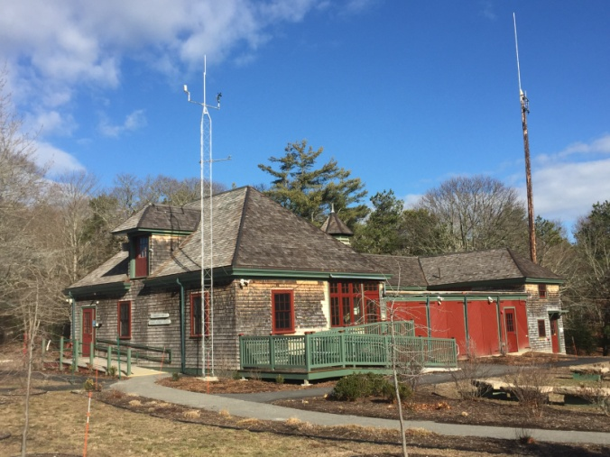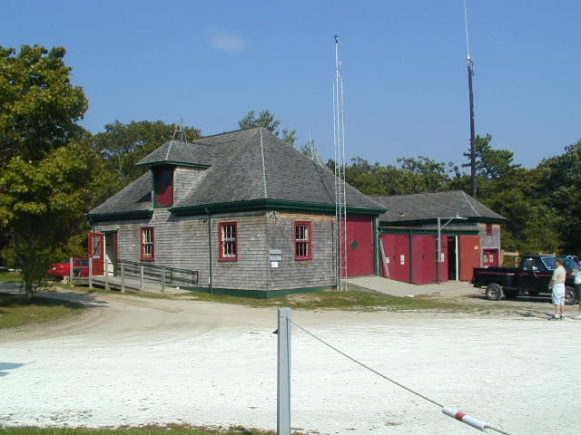

**b) 2017**

**a) 2006**

**b) 2017**

**a) 2002**

Figure 1: Photos of before (a) and after (b) the 2015 Carriage House renovation and the 2016 tower upgrade. The tower upgrade in 2016 involved a new lightening rod, grounding wire, cross bar, and upgraded temperature/relative humidity and photosynthetically active radiation sensors.

1. **2002**

Before April 18th, 2016, the LiCor Quantum Sensor (for photosynthetically active radiation readings) was mounted about 10 m east from the weather tower, where the temperature/relative humidity and wind sensors are installed. The PAR sensor pole included an extended aluminum arm at a height of 3 m (~ 10 ft) above the ground level. On April 18th, 2016, a new PAR sensor (see sensor details in Section 9) was installed on the weather tower at a height of approximately 4m (~14 ft) above ground level. Thus, current PAR readings are taken roughly 16m westward and roughly 1m higher in relation to readings taken before April 18th, 2016. However, photon scatter related to the roofline and ground should be similar between pre- and post-sensor location change. Due to shading interference in the summer months from a nearby tree, the PAR sensor was moved 10 ft higher (~24ft above ground level) on October 25th, 2016.

The air pressure sensor, which is mounted next to the CR1000 in the laboratory, is approximately 1.5 meters in height above ground level. The rain gauge is in an open field away from trees about 55 mnorthwest of the laboratory and tower and 11.2 m above sea level (NGVD). The top of the gauge is 1 meter above ground.

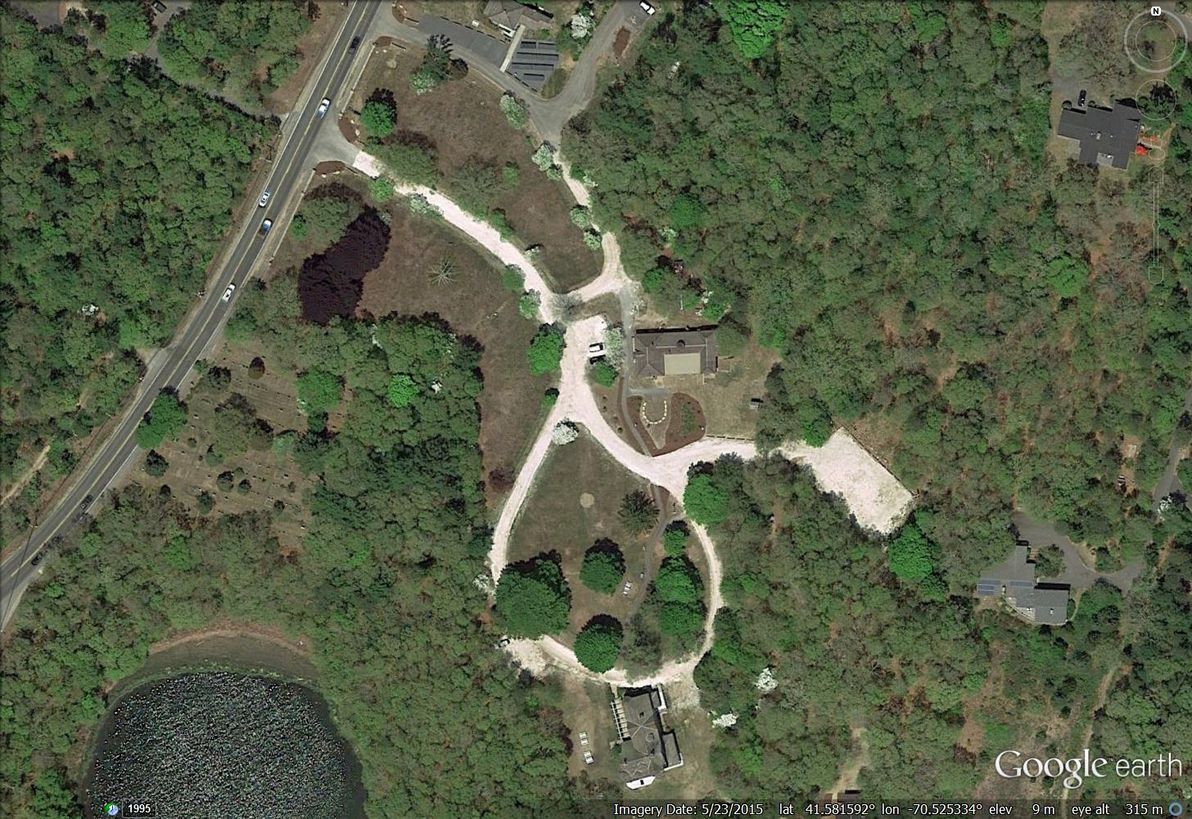

Carriage House

Visitor Center

Figure 2: The image above shows the Waquoit Bay NERR Headquarters. The red circle marks the location of the current 30-foot tower location (November 2015 – present). The yellow circle marks the past location of the wind/temperature/relative humidity tower (2006 – August 2015). The white circle marks the location of the photosynthetically active radiation sensor prior to April 18th, 2016, when the sensor was moved to the 30-foot tower (red dot). The larger blue circle indicates the location of the precipitation gauge in the open field. The barometric pressure sensor is located inside the Carriage House in the laboratory along with the CR1000 logger. Aerial provided by Google Earth (spring 2015).

As for its general setting, the Waquoit Bay National Estuarine Research Reserve (WQBNERR) is in the northeastern United States on the southern coast of Cape Cod, Massachusetts. Climatically, this region is considered temperate maritime, and experiences relatively mild winters and cool summers relative to the rest of New England because of its exposed oceanic location. Typical of the mid-latitudes (41 N), prevailing winds are from the southwest, while storm winds tend to be from the east.

The area is adjacent to one of the world’s most active regions for cyclogenesis (extra-tropical cyclone formation) off the East coast of North America. These generally winter season storms are most frequent (almost weekly) from late October until late April and are locally called Nor’easters because of the NE wind direction typical to the area during the period of peak wind speeds. These storms generally develop rapidly as secondary lows off the mid-Atlantic coast (Carolinas to New Jersey) and track northeastward passing Cape Cod either directly overhead, or to the southeast or northwest. These winter season storms are important agents of coastal erosion and shoreline alteration in the region, particularly for easterly facing coasts.

Hurricanes are also important phenomena in the region. Most years, during the period from July to November, the Cape experiences some interaction with a passing tropical storm. About once every decade the area experiences a nearby landfall, with winds exceeding hurricane threshold (>33 m/s), usually from the southerly quarter. Hurricanes are particularly important agents of change for the Cape’s southern coastal areas, and can have profound effects on local estuaries, including Waquoit Bay. Typically, barrier beach over-wash (with salt marsh burial) and breaching (with new tidal inlet formation) occur during these extreme events.

Meteorological data from Waquoit Bay NERR can be compared to that from other nearby meteorological stations. These stations are located at Otis Air Force Base (10 km to the north), Falmouth Water Department-Long Pond (8 km to the west), Woods Hole Oceanographic Institution–Quisset Campus (13 km to the southwest), Hyannis Airport (23 km to the northeast), and the Menauhant Yacht Club Local National Weather Service Reporting Station. The Menauhant Yacht Club weather station is operated and maintained by Dr. Richard Taylor as a Local National Weather Service Reporting Station (Data Garrison <https://datagarrison.com/>). Since December 2002, the National Weather Service Reporting Station has been recording daily observations at 0700 and 1900 for the following weather parameters: Temperature (oF; minimum and maximum), Precipitation (inches; rain and melted snow, snow fall, initial and endpoint times of events), Sky Conditions and Wind Speed/Direction (mph; gusts).

|  |  |  |  |  |  |  |
| --- | --- | --- | --- | --- | --- | --- |
| Station Code | SWMP Status | Station Name | Location | Active Dates | Reason Decommissioned | Notes |
| WQBCHMET | P | Carriage House | 41°34’54.09” N,  70°31’30.65”W | Jan 2002 - present | NA | Moved slightly in 2015; upgrade in 2016 |
|  |  |  |  |  |  |  |

**6) Data collection period –**

|  |  |  |  |  |
| --- | --- | --- | --- | --- |
| **START Time** | **Date** |  | **END Time** | **Date** |
| **00:00** | **01/01/2023** |  | **15:00** | **01/23/2023** |
| **15:15** | **01/23/2023** |  | **09:15** | **02/27/2023** |
| **09:30** | **02/27/2022** |  | **08:15** | **03/23/2023** |
| **08:30** | **03/23/2023** |  | **08:40** | **04/27/2023** |
| **08:40** | **04/27/2023** |  | **08:15** | **05/24/2023** |
| **08:15** | **05/24/2023** |  | **14:15** | **06/22/2023** |
| **14:15** | **06/22/2023** |  | **14:34** | **07/27/2023** |
| **14:34** | **07/27/2023** |  | **13:46** | **08/24/2023** |
| **13:46** | **08/24/2023** |  | **11:15** | **09/27/2023** |
| **11:15** | **09/27/2023** |  |  |  |
|  |  |  |  |  |

**7) Distribution –**

NOAA retains the right to analyze, synthesize and publish summaries of the NERRS System-wide Monitoring Program data.  The NERRS retains the right to be fully credited for having collected and processed the data.  Following academic courtesy standards, the NERR site where the data were collected should be contacted and fully acknowledged in any subsequent publications in which any part of the data are used.  The data set enclosed within this package/transmission is only as good as the quality assurance and quality control procedures outlined by the enclosed metadata reporting statement.  The user bears all responsibility for its subsequent use/misuse in any further analyses or comparisons.  The Federal government does not assume liability to the Recipient or third persons, nor will the Federal government reimburse or indemnify the Recipient for its liability due to any losses resulting in any way from the use of this data.

Requested citation format:

NOAA National Estuarine Research Reserve System (NERRS). System-wide Monitoring Program. Data accessed from the NOAA NERRS Centralized Data Management Office website: <http://www.nerrsdata.org/>; *accessed* 12 October 2023.

NERR meteorological data and metadata can be obtained from the Research Coordinator at the individual NERR site (please see Principal Investigators and Contact Persons), from the Data Manager at the Centralized Data Management Office (please see personnel directory under the general information link on the CDMO home page) and online at the CDMO home page [www.nerrsdata.org](http://www.nerrsdata.org).  Data are available in comma delimited format.

**8) Associated researchers and projects –**

As part of the SWMP long-term monitoring program, WQB NERR also collects 15-minute water quality data and monthly grab and diel samples for nutrient/pigment data which may be correlated with this meteorological dataset. The water quality monitoring and nutrient sampling occur at four water quality stations located throughout the Waquoit Bay Estuary: Childs River (tidal riverine system with high nitrogen load), Menauhant Yacht Club (closest proximity to ocean influence from Vineyard Sound), Sage Lot Pond (tidal pond surrounded by polyhaline salt marshes), and Metoxit Point (open water location inside Waquoit Bay). These data are available at [www.nerrsdata.org](http://www.nerrsdata.org).These data are available at [www.nerrsdata.org](http://www.nerrsdata.org).

**II. Physical Structure Descriptors**

**9) Sensor specifications –**

Temperature

*Starting April 18th, 2016*

Units: Celsius

Sensor type: PT100 RTD, IEC 751 1/3 Class B, with calibrated signal conditioning

Model #:  HC2-S3 Temperature and Relative Humidity Probe

Operating Temperature:  -40°C to +60°C

Range: -40°C to +60°C

Accuracy: ± 0.1 °C @ 23°C

S/N: 0020052725

Date of last calibration: 04/13/2018

Dates of sensor use: 04/18/2016 – 06/08/2017, 11/09/2017 – 1/19/2018, 05/03/2018 – 06/24/2019, 03/03/2020 – current as of 01/31/2022

S/N: 0020072974

Date of last calibration: 05/22/2019

Dates of Sensor Use: 06/08/2017 – 11/09/2017, 1/19/2018 – 05/03/2018, 06/24/2019 – 03/03/2020

Relative Humidity (RH)

*Starting April 18th, 2016*

Units: Percent

Sensor type: ROTRONIC® Hygromer IN-1

Model #: HC2-S3 Temperature and Relative Humidity Probe

Range: 0-100% non-condensing

Accuracy at 23°C:  +/- 0.8% RH with standard configuration settings

Temperature dependence of RH measurement +/- 3% (-40 to 60C)

S/N: 0020052725

Date of last calibration: 04/13/2018

Dates of sensor use: 04/18/2016 – 06/08/2017, 11/09/2017 – 1/19/2018, 05/03/2018 – 06/24/2019, 03/03/2020 – current as of 01/31/2022

S/N: 0020072974

Date of last calibration: 05/22/2019

Dates of Sensor Use: 06/08/2017 – 11/09/2017, 1/19/2018 – 05/03/2018, 06/24/2019 – 03/03/2020

Photosynthetically Active Radiation (PAR)

*Starting April 18th, 2016*

Units: mmoles m2 (total flux)

Sensor type: anodized aluminum with cast acrylic diffuser

Model #SQ110 Apogee Quantum Sensor

Light spectrum waveband: 410 to 655 nm

Temperature dependence: 0.06+/-0.06% per °C

Stability: <±2% change over 1 yr

Operating Temperature: -40°C to 70°C; Humidity 0 to 100%

Cosine Response: 45° zenith angle: +/- 2%; 75° zenith angle: +/- 5%

Sensitivity: 0.2mV per µmol s-1 m-2

S/N: 20507

Date of last calibration: 04/18/2018

Dates of Sensor Use: 04/18/2016 – 03/28/2018,

05/03/2018 – current as of 01/31/2022

Wind Speed

Units: meter per second (m/s)

Sensor type: 18 cm diameter 4-blade helicoids propeller molded of polypropylene

Model: RMY 05103

Range:

0-60 m/s (134 mph)

gust survival 100 m/s (220 mph)

Direction Range: 360° Threshold Sensitivity: 0.5 m/s (1.1 kts) at 10° displacement

Accuracy: +/- 0.3 m/s

S/N: 09834

Date of last calibration: 06/29/2016

Dates of Sensor Use: 6/27/2012–12/04/2015,

10/25/2016 – 10/30/2018

08/09/2019 – 11/26/2019

S/N: 87990

Date of last calibration: 10/30/2019

Dates of Sensor Use: 10/30/2018 – 08/09/2019 *(potentiometer failed on 04/26/2019)*

11/26/2019 – current as of 01/31/2022

Wind Direction

Units: degrees

Sensor type: balanced vane, 38 cm turning radius

Model: RMY 05103

Direction Range: 360° Threshold Sensitivity: 0.5 m/s (1.1 kts) at 10° displacement

S/N: 09834

Date of last calibration: 06/29/2016

Dates of Sensor Use: 6/27/2012–12/04/2015,

10/25/2016 – 10/30/2018

08/09/2019 – 11/26/2019

S/N: 87990

Date of last calibration: 10/30/2019

Dates of Sensor Use: 10/30/2018 – 08/09/2019 *(potentiometer failed on 04/26/2019)*

11/26/2019 – current as of 01/31/2022

Barometric Pressure

*Starting 06/08/2017*

Units: millibars (mb)

Sensor Type: Vaisala Barocap © silicon capacitive pressure sensor

Model #: CS 106 Vaisala PTB101B

Operating Range:

Pressure: 500-1100 mb

Temperature: -40 to +60°C

Humidity: non-condensing

Accuracy:

±0.3 mb (@ +20°C)

±0.6 mb (@ 0° to 40°C)

±1.0 mb (@ -20° to +45°C)

±1.5 mb (@ -40° to +60°C)

Stability: ± 0.1 mb per year

S/N: N0220822

Date of last calibration: 01/11/2017 (new, received 05/16/2017)

Dates of Sensor Use: 06/08/2017 – 06/24/2019

S/N: D3140010

Date of last calibration: 05/22/2019

Dates of Sensor Use: 06/24/2019 – current as of 01/31/2022

Precipitation

Units: millimeters (mm)

Sensor Type: Heated Tipping Bucket Rain Gauge

Model #: 385L

Rainfall per tip: 0.01 inch

Operating range: Temperature: 0° to 50°C; Humidity: 0 to 100%

Accuracy:

±0.5% @ < 0.5” (1.25 cm)/hr rate

±2.0% @ < 3.0” (7.50 cm)/hr rate

S/N: C1521

Date of last calibration: 06/24/2021

Dates of Sensor Use: 9/9/2011 - current as of 01/31/2022

The CR1000 has two MB Flash EEPROM that are used to store the Operating System. Another 128 K Flash is used to store configuration settings. A minimum of 2 MB SRAM is (4 MB optional) is available for program storage (16K), operating system use, and data storage. Additional storage is available by using a compact flash card in the optional CFM100 Compact Flash Module. This station was installed on 7/12/2006. Additional CR1000 specification can be found at: <http://www.campbellsci.com/documents/lit/s_cr1000.pdf>.

S/N: 5246

Manufacture Year: 2006

Dates CR1000 Installed: 07/12/2006 – 06/07/2016,

10/25/2016 – current as of 01/31/2022

Date CR1000 Calibrated: 06/21/2016

CR1000 Firmware Version: CR1000.Std.32.05 (updated: 05/21/2020)

CR1000 Program Version: wqbchmet_6.3.3_052517.cr1

Campbell Charger for CR1000: Model # CH 100, 12 V

**10) Coded variable definitions -**

Sampling station: Sampling site code: Station code:

Carriage House CH wqbchmet

**11) QAQC flag definitions –**

QAQC flags provide documentation of the data and are applied to individual data points by insertion into the parameter’s associated flag column (header preceded by an F_). During primary automated QAQC (performed by the CDMO), -5, -4, and -2 flags are applied automatically to indicate data that is above or below sensor range, or missing. All remaining data are then flagged 0, as passing initial QAQC checks. During secondary and tertiary QAQC 1, -3, and 5 flags may be used to note data as suspect, rejected due to QAQC, or corrected.

-5 Outside High Sensor Range

-4 Outside Low Sensor Range

-3 Data Rejected due to QAQC

-2 Missing Data

-1 Optional SWMP supported parameter

0 Passed Initial QAQC Checks

1 Suspect Data

2 *Open - reserved for later flag*

3 *Open - reserved for later flag*

4 Historical Data: Pre-Auto QAQC

5 Corrected Data

**12) QAQC code definitions** –

QAQC codes are used in conjunction with QAQC flags to provide further documentation of the data and are also applied by insertion into the associated flag column. There are three (3) different code categories, general, sensor, and comment. General errors document general problems with the CR1000/CR1000X, sensor errors are sensor specific, and comment codes are used to further document conditions or a problem with the data. Only one general or sensor error and one comment code can be applied to a particular data point, but some comment codes (marked with an * below) can be applied to the entire record in the F_Record column.

General Errors

GIM Instrument malfunction

GIT Instrument recording error, recovered telemetry data

GMC No instrument deployed due to maintenance/calibration

GMT Instrument maintenance

GPD Power down

GPF Power failure / Low battery

GPR Program reload

GQR Data rejected due to QA/QC checks

GSM See metadata

Sensor Errors

SDG Suspect due to sensor diagnostics

SIC Incorrect calibration constant, multiplier or offset

SIW Incorrect wiring

SMT Sensor maintenance

SNV Negative value

SOC Out of calibration

SQR Data rejected due to QAQC checks

SSD Sensor drift

SSN Not a number / unknown value

SSM Sensor malfunction

SSR Sensor removed

Comments

CAF Acceptable calibration/accuracy error of sensor

CCU Cause unknown

CDF Data appear to fit conditions

CML Snow melt from previous snowfall event

CRE* Significant rain event

CSM* See metadata

CVT* Possible vandalism/tampering

CWE* Significant weather event

**13) Other remarks/notes** –

Data are missing due to equipment or associated specific sensors not being deployed, equipment failure, time of maintenance or calibration of equipment, or repair/replacement of a sampling station platform. Any NANs in the dataset stand for “not a number” and are the result of low power, disconnected wires, or out of range readings. If additional information on missing data is needed, contact the Research Coordinator at the reserve submitting the data.

[Remove if not applicable – this applies only to the LI-COR sensor] Small negative PAR values are within range of the LI-COR sensor and are due to normal errors in the sensor and the CR1000 Datalogger. The Maximum signal noise error for the LI-COR sensor is +/- 2.214 mmoles/m2 over a 15 minute interval. These values are automatically flagged and coded as <1> (CAF).

Relative Humidity data greater than 100 are within range of the sensor accuracy of +/-3% and are flagged and coded as suspect, <1> (CAF). Values greater than 103 are rejected <-3>.

Data recorded for all parameters (with the exception of cumulative precipitation) at the midnight timestamp (00:00) are the 15 minute averages and totals for the 23:45-23:59 time period of the previous day. Cumulative precipitation data at the midnight timestamp (00:00) are the sum of raw (unrounded) precipitation data from 00:00 to 23:59 of the previous day. Summing each individual 15-minute total precipitation value from the same period will result in small differences from cumulative precipitation due to rounding. It is especially important to note how data at the midnight timestamp are recorded when using January 1st and December 31st data. **Note: Cumulative precipitation is no longer available via export from the CDMO. Please contact the reserve or the CDMO for more information or to obtain these data.**

Precipitation data collected with rain gauges that are not designed specifically for measuring frozen precipitation (snow/ice/hail), including heated gauges and those that use antifreeze to melt frozen precipitation, may not be measured accurately. Blowing wind, sublimation, and rate of snowfall/ice melt all effect the amount of recorded precipitation. The reserve has made attempts to accurately record dates and times when frozen precipitation and subsequent melting has occurred.

*Specific 2023 Metadata Notes (all times provided in EST):*

**General:**

* On 10/25/2021 the CR1000 surpassed the 5-year calibration period, and due to staffing shortages was not able to be calibrated or replaced. Because of this, all parameters are flagged as suspect <1> [GSM].
* The Temperature/Relative Humidity sensor and PAR sensors also surpassed their recommended calibration period in 2021 and are labeled as suspect as well. See below for more information.

**Temperature and Relative Humidity (RH):**

* 01/01/2023 to 01/04/2024 11:30, <1>[SOC](CSM) – The currently installed temp/RH probe (SN# 20052725) surpassed the recommended period between calibrations on 05/03/2020. Because this sensor has performed better (fewer sporadic readings) than SN#20072974, we have kept it installed. Additionally, due to the COVID-19 pandemic, delays in establishing a MA State vendor contract with Campbell Scientific Inc., and staffing issues throughout 2021-2022, replacing the sensor has been temporarily postponed.
* 01/12/2023 21:30, 22:30 <-3>[SQR] – The data was rejected because the values were higher than expected, and the currently installed temp/RH probe (SN# 20052725) surpassed the recommended period between calibrations on 05/03/2020.
* 01/12/2023 23:15 – 01/13/2023 02:45 <-3>[SQR] – The data was rejected because the values were higher than acceptable calibration error for the sensor. The currently installed temp/RH probe (SN# 20052725) surpassed the recommended period between calibrations on 05/03/2020. Several other individual examples and prolonged time periods flagged in the same way exist between this time and 01/29/2023 19:30 as well.
* 03/23/2023 11:45 – 12:15 <-3>[SQR] – Data rejected because it does not fit conditions of surrounding values.
* 10/10/2023 11:45 <-3>[SQR] – Data rejected because Maximum Temperature and MinimumTemperature difference during the 15 minute sampling period was more than 3 degrees. Other examples of this occur at the following times:
  + 11/03/2023 08:00 <-3>[SQR]
  + 11/18/2023 12:00 <-3>[SQR]
  + 12/10/2023 15:45 <-3>[SQR]

**PAR (Photosynthetically Active Radiation):**

* 01/01/2023 to 01/04/2022 11:30, <1>[SOC](CSM) – On 05/03/2021 the PAR sensor surpassed recommended calibration standards and all data following this date are marked suspect until the PAR sensor could be replaced with a recently calibrated unit. Due to complications related to delayed vendor contract development and failed ordering systems with Campbell Scientific Inc., the sensor replacement was delayed for several months. Due to staffing issues, the new equipment was not yet installed.

**Total Precipitation (TotPrcp)**

* 08/08/2023 11:00, <0>[GSM](CRE) – The 28.2 mm value was initially flagged as high. A significant storm came through the area with intense rainfall, high winds, and included a tornado warning as well.